Phytochemical Component Analysis of Basil

Student’s Name
Institutional Affiliations
Date

Abstract
The basil plant contains the various chemical composition. These chemical components of the basil plant can be extracted from their leaves or flowers. The chemical composition of the basil contributes many benefits to the field of medicine. The basil chemical components can be used for various medical uses such as manufacturing medicine and other food industry applications. This report will analyze various articles related to the hydroponic cultivation of basil and the phytochemical composition of the basil. Mainly, the report will involve a detailed review of six articles. However, the report begins with introducing the Major concept to be discussed in the report and the motivation for the study. Lastly, the report will include a conclusion of the topic is discussed in the articles.

Table of Contents
Phytochemical Component Analysis of Basil 3
The motivation for review 4
The focus of study 4
Article one 4
Article Two 6
Article 3 7
Article 4 8
Article 5 9
Article 6 9
Conclusion. 10
References 11

Phytochemical Component Analysis of Basil
The basil plant contains the various chemical composition. These chemical components of the basil plant can be extracted from their leaves or flowers. The chemical composition of the basil contributes many benefits to the field of medicine. The basil chemical components can be used for various medical uses such as manufacturing medicine and other food industry applications. This report will include a detailed analysis of the phytochemical components of hydroponically cultivated basil. The analysis will include the review of some articles to help analyses the views and research conducted by various authors to help identify various phytochemical components of hydro cultivated basil. Further, the report will include a detailed explanation of the motivation for reviewing the articles and the entire study.

The motivation for the review
Several factors have influenced this study and the complete analysis of the phytochemical composition of the hydroponically cultivated basil. One of the major factors that facilitate this study is to enhance the understanding of the various phytochemical composition of the hydroponically cultivated basil. A detailed review of several articles from different authors will help understand the chemical composition of hydroponically cultivated basil. The use of articles from different authors will help compare the different understanding of the components of hydroponically cultivated basil.

The focus of the study
Using articles from different authors, this report will concentrate on the views and the understanding of the chemical composition of the phytochemical composition of hydroponically cultivated basil. The report will critically analyze the research work done by different authors and analyze the findings of the composition of the basil. Critical analysis of the research work and the findings of different authors on the phytochemical composition of hydroponically cultivated basil will help get a detailed analysis of the various components of hydroponically cultivated basil.

Article one
Salas-Pérez, L., Fornari-Reale, T., Preciado-Rangel, P., García-Hernández, J. L., Sánchez-Chávez, E., & Troyo-Diéguez, E. (2018). Cultivar variety and added potassium influence the nutraceutical and antioxidant content in hydroponically grown basil (Ocimum basilicum L.). Agronomy, 8(2), 13.
This article describes the chemical composition of the hydroponically cultivated basil. The authors insist on identifying potassium composition, which is one of the major chemical components of basil. The authors assess the various components of the nutrients, especially potassium, on various aromatic crops and basil. The authors use a structure that blackly designed to analyze the components of nutrients in the polyphenolic composites and vitamin C and other phytochemical components of a variety of basil. This article bases its argument on the three variety of basils.
The researchers analyze the phytochemical components of the three varieties of basil where they found out that there is a notable difference in the variance analysis of the three types of basils. The variance among the three variety of basil resulted from the genotype and the composition of potassium. However, the antioxidant volume of the hydroponically cultivates basil was increased when there was the input of potassium in the solution (Salas-Pérez et al.,.2018). These lead to a positive correlation to the composition of flavonoids, anthocyanins. The authors conclude that the antioxidant nature of the hydroponic basis, the DPPH analysis shows a linear propensity for higher doses of potassium. Further, they concluded that the composition of the nutraceutical elements could be improved by increasing the composition of potassium in the solution.
The graph below shows the effects of potassium solution on basil.
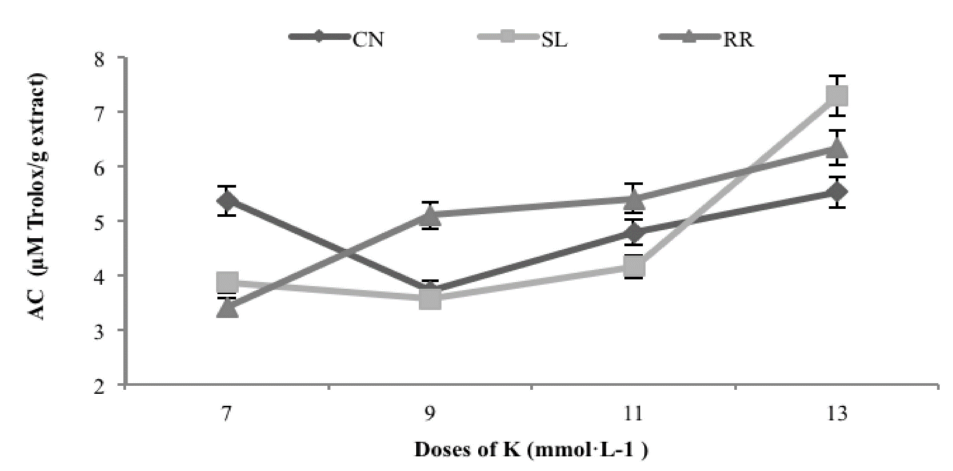

Article Two
Priss, OP, Pris, OP, Korotka, IO, Korotkaya, IA, Klipakova, Yu. O., Klipakova, Yu. A., & Belousova, Z. W. (2020). The dry matter fund of green cornflowers depends on the substrate's component composition.
This article involves the nutrition and growth of basil which is cultivated hydroponically. The article further compares the yield of the basil and other aquatic organisms and, in this case, the cry fish. The author aims at investigating how the cry fish and its influences on the basil plant. The article explains the nutrient relationship between the crayfish and the basil plant. Further, the author collected samples on both fresh and dry basils to measure their weight and nutrient value.
The article further suggests that the waste from the cry fish help to add nutrient values to the basil plant. The author also indicates that there the importance of basil in human health. Bail contains chemical components that help to manufacture medicine to cure some human diseases. The authors also illustrate that basil can be used as an ingredient to make perfumes due to its pleasant scent. The author concludes that the chlorophyll composition is one of the key determinants of the quality of the basil (Priss et al. 2020). The authors argued that the more the chlorophyll composition of basil, the more the nutrient value of the basil. Lastly, it is evidenced that there is a close relationship between the aquatic crayfish and the hydroponically cultivated basil.

Article 3
Jacob, J. K. S., Carlos, R. C. A., & Divina, C. C. (2016). Phytochemical composition, antibacterial and antifungal activities of sweet basil (Ocimum basilicum). Advances in Environmental Biology, 10(7), 84-90.
This article involves an analysis of the phytochemical composition of the basil, which is used to made medicinal drugs. The author illustrates various chemical composition which helps in making drugs. The author illustrates various uses of medicine extracted from the basil plant. One of the uses of the chemical extraction of basil is that it is used as an antibacterial drug and antifungal drug. The author illustrates that some chemical elements are extracted from the leaves of the basil plant.
The author illustrates that the chlorophyll composition of the basil plant affects the quality of the chemical extracted from the leaves of the plants. Further, the author illustrates that the flowers of the sweet basil can also be used to extract important chemical materials used to make antibacterial and anti-fungi drugs (Jacob, Carlos & Divina, 2016). Further, the author researched to investigate the phytochemical composition of sweet basil under a hydroponic environment. The author found out that the hydroponically cultivated basil contains at least eight phytochemical elements, which are important in making medicine. The articles show that the hydroponically cultivated basil contains phytochemical components that help are used as herbs and as raw materials for making antibacterial and antifungal drugs.

Article 4
Skrypnik, L., Novikova, A., & Tokupova, E. (2019). Improvement of phenolic compounds, essential oil content and antioxidant properties of sweet basil (Ocimum basilicum L.) depending on type and concentration of selenium application. Plants, 8(11), 458.
This article involves the hydroponic cultivation of basil. The authors give a detailed explanation of various ways to increase the yield and the productivity of the basil. Further, the author explains the importance of basil in the field of medicine. In this case, the author explains that basil is essential in extracting medicinal drugs from its leaves (Skrypnik, Novikova & Tokupova, 2019). The author explains that the chlorophyll composition of the basil determines the quality of the drugs produces. The author indicates that the application of foliar feed to basil help increase the chlorophyll composition of the leaves hence increasing the quality of the medicinal drugs extracted from the leaves.
Further, the author illustrates that the exposure of the basil to sunlight help increase the quality of the phytochemical composition of the basil. In conclusion, the article indicates that the application of various measures such as the use of foliar feed and increase in the amount of light to the basil plant help increase the productivity of the plant. The leaves of the basil plant provide essential phytochemical products which are used for medicinal purposes.

Article 5
Poonkodi, K. A. T. H. I. R. V. E. L. (2016). The chemical composition of essential oil of Ocimum basilicum L.(basil) is a biological activities-an overview. J. Crit. Rev, 3(3), 56-62.
This article explains the various chemical composition of basil. The author indicates their various uses of the phytochemical constituents of the basil product (Poonkodi, 2016). The author reports from a report conducted by others that shows the basil phytochemical products are used to make medicine that reduces the risks of cancer infection.
The author further explains that the use of basil products helps in reducing the infection of cancer. Further, the author illustrates the use of basil product as an insecticide. Lastly, the author concludes that basil phytochemical compounds are essential to human life.

Article 6
Alhasan, A. S., Abbas, M. K., & Al-Ameri, D. T. (2021, April). Response of Two Purple basil (Ocimum basilicum L.) Cultivars Grown Under Field Conditions to Different Rates of NPK Foliar Fertilization. In IOP Conference Series: Earth and Environmental Science (Vol. 735, No. 1, p. 012053). IOP Publishing.
This article discusses the finding obtained from research conducted by a group of scientists on a pair of purple basil cultivated under hydroponic condition. The authors explain that each basil was treated with a different amount of NPK to help increase the productivity of the leaves. The research concluded that the input of the NPK affects the productivity of the basil (Alhasan, Abbas, & Al-Ameri, 2021). Further, the article shows that NPK and other fertilizer help improve the quality of the basil phytochemical composition. The author states that the phytochemical components extracted from basil help make various medicines in the pharmaceutical sector.

Conclusion.
From the study above, it is evidenced that there several phytochemical compositions of hydroponically cultivated basil. From the articles above, basil contains the chemical components essential in making medicine and other insecticides. Further, the articles discuss several ways of improving the productivity of basil, such as inputting foliar fertilizer. Additionally, the report explains that the chlorophyll composition of the basil influences the quality of the phytochemical composition of the basil plant.

References
Salas-Pérez, L., Fornari-Reale, T., Preciado-Rangel, P., García-Hernández, J. L., Sánchez-Chávez, E., & Troyo-Diéguez, E. (2018). Cultivar variety and added potassium influence the nutraceutical and antioxidant content in hydroponically grown basil (Ocimum basilicum L.). Agronomy, 8(2), 13.
Priss, OP, Pris, OP, Korotka, IO, Korotkaya, IA, Klipakova, Yu. O., Klipakova, Yu. A., & Belousova, Z. W. (2020). The dry matter fund of green cornflowers depends on the substrate's component composition.
Jacob, J. K. S., Carlos, R. C. A., & Divina, C. C. (2016). Phytochemical composition, antibacterial and antifungal activities of sweet basil (Ocimum basilicum). Advances in Environmental Biology, 10(7), 84-90.
Skrypnik, L., Novikova, A., & Tokupova, E. (2019). Improvement of phenolic compounds, essential oil content and antioxidant properties of sweet basil (Ocimum basilicum L.) depending on type and concentration of selenium application. Plants, 8(11), 458.
Poonkodi, K. A. T. H. I. R. V. E. L. (2016). Chemical composition of essential oil of Ocimum basilicum L.(basil) is a biological activities-an overview. J. Crit. Rev, 3(3), 56-62.
Alhasan, A. S., Abbas, M. K., & Al-Ameri, D. T. (2021, April). Response of Two Purple basil (Ocimum basilicum L.) Cultivars Grown Under Field Conditions to Different Rates of NPK Foliar Fertilization. In IOP Conference Series: Earth and Environmental Science (Vol. 735, No. 1, p. 012053). IOP Publishing.

